**Exercise: Create a sales report**

**Introduction**

Sales reports are critical tools for business owners, stakeholders, and decision-makers. They provide essential insights into how a company's products or services are performing in the market—guiding decisions and shaping future strategies. In this exercise, you'll explore how you can use Power BI’s data visualization capabilities to create an interactive sales report.

**Case study**

As the data analyst at Adventure Works, creating sales reports is critical to your role. By analyzing sales performance, you can help the company identify trends and areas for improvement, assess business performance and progress toward goals, plan and allocate resources, and ultimately make data-driven decisions. Say the sales department requests a sales report demonstrating Adventure Works' sales revenue over time. The sales dataset you'll use for the report consists of rows representing a transaction with various data points, such as **Product Category**, **Product Name, Order Date**, and **Total Sales**.

**Instructions**

Download and open the Power BI file, *Create a sales report*.

[Create-a-sales-report](https://d3c33hcgiwev3.cloudfront.net/llkYZ2beRNWkLQuvx1-osw_26290104073441f6acf68b2588daf3e1_Create-a-sales-report.pbix?Expires=1711238400&Signature=a2XlD8Go5eDKPqlrjIHAxqcq6HzurxzSxQIbBvvnw23rX3096xo7ZkHwC~0v7WamSYVokn3WOGz3pILp8MmkdO1kyQ0lpxE4e4Kx9hgVe7in87IhhPwzBCG57Nl~brrBJsVDhEleQ9HYR2VBz-Z7HaXxPBsfkIrykJi0jq2IGhs_&Key-Pair-Id=APKAJLTNE6QMUY6HBC5A" \t "_blank)

[PBIX File](https://d3c33hcgiwev3.cloudfront.net/llkYZ2beRNWkLQuvx1-osw_26290104073441f6acf68b2588daf3e1_Create-a-sales-report.pbix?Expires=1711238400&Signature=a2XlD8Go5eDKPqlrjIHAxqcq6HzurxzSxQIbBvvnw23rX3096xo7ZkHwC~0v7WamSYVokn3WOGz3pILp8MmkdO1kyQ0lpxE4e4Kx9hgVe7in87IhhPwzBCG57Nl~brrBJsVDhEleQ9HYR2VBz-Z7HaXxPBsfkIrykJi0jq2IGhs_&Key-Pair-Id=APKAJLTNE6QMUY6HBC5A" \t "_blank)

**Note:** If your data import was successful, the **Fields** pane on the right side of the screen should list the Adventure Works sales data columns like **Order Date**, **Order Total**, and **Product Category**. The **Fields** pane lists all your data columns from the imported datasets. With your data imported successfully, follow the prompts below to complete the exercise.

**Step 1: Create a line chart for sales revenue over time**

1. First, select the **Sales Revenue over Time** page.
2. Navigate to the **Visualizations** pane to create a simple line chart to visualize Adventure Works' sales revenue over time. The pane is on the right side of your screen, marked by an icon resembling a bar graph.
3. Once in the **Visualizations** pane, find and select the **Line Chart** icon represented by a jagged line ascending across a grid to create a standard line chart. An empty chart should appear in the center of your Power BI canvas.
4. To populate the empty chart with data, you'll need to drag and drop the relevant fields into the appropriate chart areas. To do this, find **Order Date > Month** in the **Fields** pane. Drag it across to the **X-Axis** field well under the **Visualizations** pane.
5. Similarly, find **Order Total** in the **Fields** pane. Drag it to the **Y-Axis** field well. When the **Y-Axis** highlights, drop **Order Total** into it.

By completing the above steps, your line chart will display the total sales over time. **Note:** You can adjust the chart's size by clicking and dragging its edges.

**Step 2: Create a pie chart for sales by product category**

Next, let's create a pie chart visualizing sales by product category, a valuable tool for Adventure Works to understand the contribution of each product category to its total sales.

1. Begin by selecting the **Sales by Product Category** page.
2. Select the **Pie chart** icon in the **Visualizations** pane to start creating your pie chart. A blank pie chart box should appear in your report canvas.
3. To add data to your pie chart, locate the **Product Category** field in your sales dataset. Then, select and hold the **Product Category** field, and drag it over to the **Legend** box.
4. Next, locate the **Order Total** field, then select and drag it over the **Values** box. **Note**: The **Order Total** field represents each order's total sales amount in monetary value (USD). Power BI automatically sums up the order totals for each product category you visualize.

At this point, you should have created your pie chart. Hovering over each slice will display a tooltip with the exact sales figure.

**Step 3: Create a stacked bar chart as sales by day of the week**

Visualizing sales by day of the week complements the broader picture of sales revenue over time as it facilitates more precise, data-driven decision-making to enhance business performance. To create a bar chart for this analysis:

1. Select the **Sales by Day of Week** page.
2. Navigate to the **Visualizations** pane on the right side of the screen. Select the **Stacked bar chart** icon. A blank bar chart box will appear on your report canvas.
3. To add data to your bar chart, find the **Order Day of Week** field in the **sales** dataset and drag it to the **Y-Axis** field well.
4. Next, locate the **Order Total** field and drag it to the **X-Axis** field well.

After completing these steps, you should have a bar chart representing the sales by day of the week, where the bar height corresponds to the total sales for that day.

**Step 4: Add a slicer visual to alter the data to reflect changes**

Slicers can provide Adventure Works with a way to filter data interactively, enabling stakeholders to select one or more items and filter the rest of the visuals in the report accordingly. To create a slicer:

1. Select the **Sales by Day of Week** page.
2. Navigate to the **Visualizations** pane on the right side of the screen. Select the **Slicer** icon. An empty slicer box will appear on your report canvas.
3. To add data to your slicer, find the **Order Date** field in the **Sales** dataset and drag it to the **Field** well.

**Conclusion**

As a data analyst, insights gained from the sales reports you create in Power BI can guide a company's direction, shape its future strategies, and play a crucial role in its success. Your work is not just about extracting information from datasets but leading companies like Adventure Works to growth and success.

**Exemplar: Create a sales report**

**Introduction**

In the exercise *Create a sales report*, you were tasked with creating a sales report for Adventure Works, providing the company with insights into its business performance. Specifically, you were asked to:

* Create a line chart to track sales revenue over time, enabling Adventure Works to identify sales peaks, trends, and patterns.
* Visualize the contribution of each product category to total sales using a pie chart.
* Produce a bar chart demonstrating sales by day of the week, reflecting customer buying patterns.

This reading is a guide you can use to compare your work. Your answers may differ from the example answers provided but still be correct.

**Power BI Desktop user interface**

In this exercise, you created visualizations using Power BI Desktop. Power BI Desktop is updated and released monthly, incorporating customer feedback and new features. You might experience changes in the Power BI Desktop User Interface (UI) that have taken place after the development of this training content. As a result, the screenshots in the videos, readings, or exercises, including the current reading, might not align exactly with how you experience the UI. However, please note that these changes do not impact the functionalities of the UI. Hence, you can still perform all the steps shown in that video, reading, or exercise.

**Create a sales report**

**Step 1: Create a line chart for sales revenue over time**

1. First, select the **Sales Revenue over Time** page.
2. To create a line chart (a helpful visualization for depicting changes over time, allowing for clear visualization of trends, fluctuations, and patterns), navigate to the **Visualizations** pane.

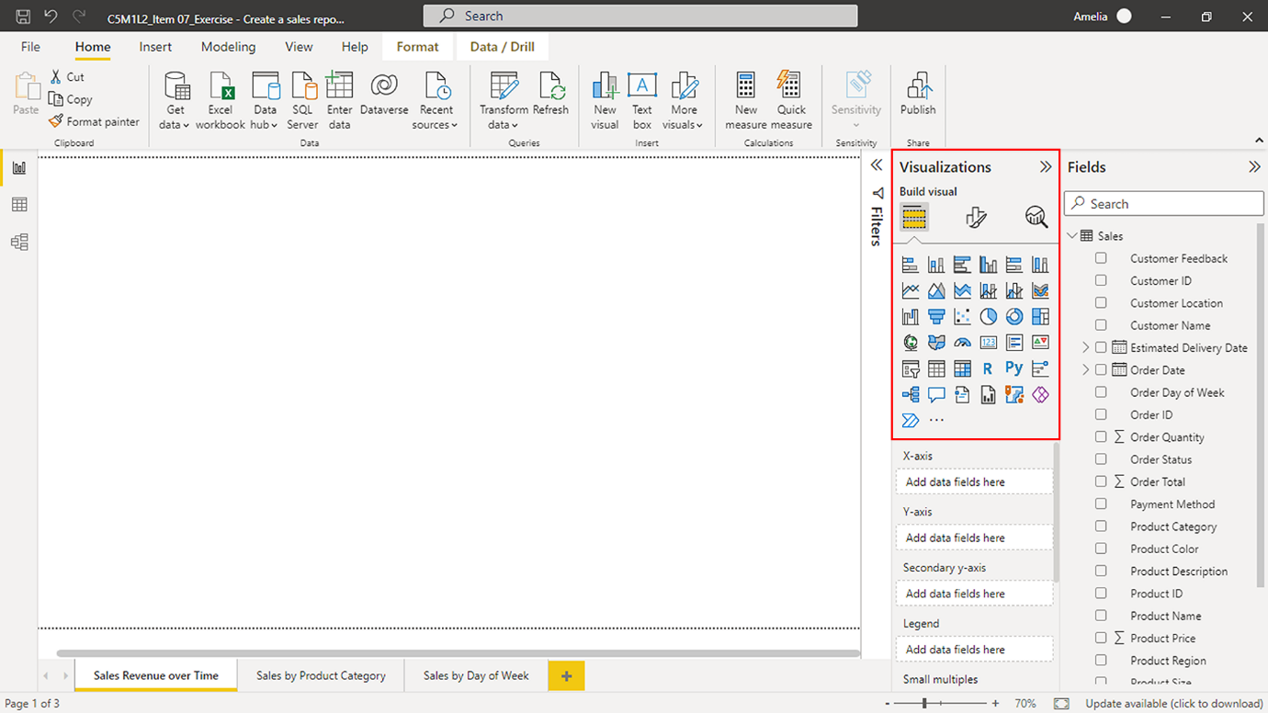

1. Select the **Line chart** icon. An empty chart should appear in the center of your Power BI canvas.

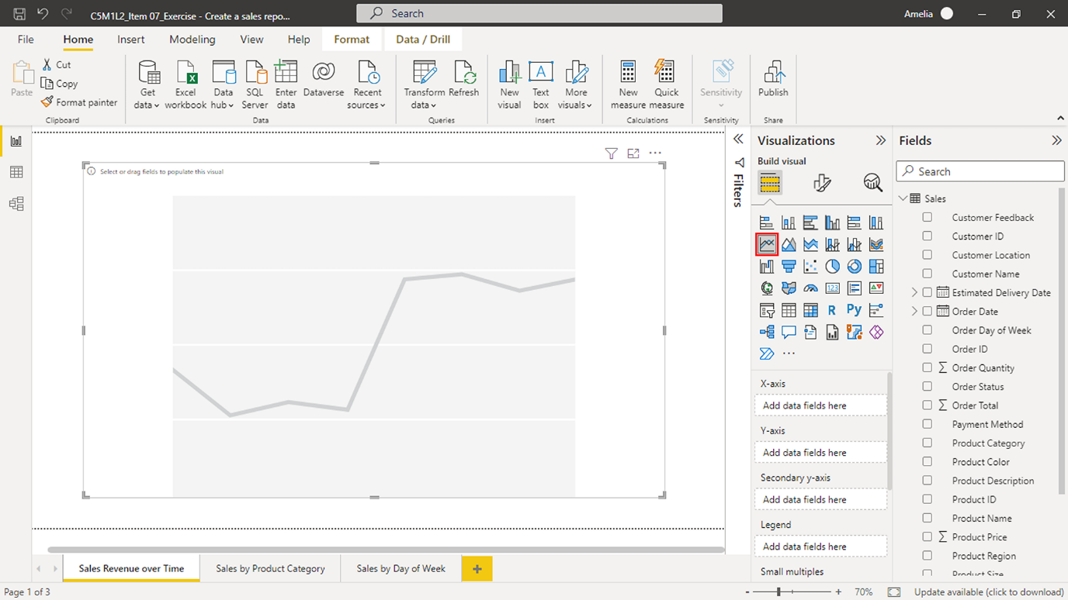

1. To start populating this chart with data (by dragging and dropping the relevant fields into the appropriate chart areas), select, hold, and drag the **Order Date > Month** field across to the **X-Axis** field well under the **Visualizations** pane. **Note:** **Order Date** will populate the **X-Axis** area when you release the mouse button. Assigning **Order Date > Month** to the **X-Axis** sets the foundation of your time series analysis. In other words, it defines the time frame for sales data analysis.

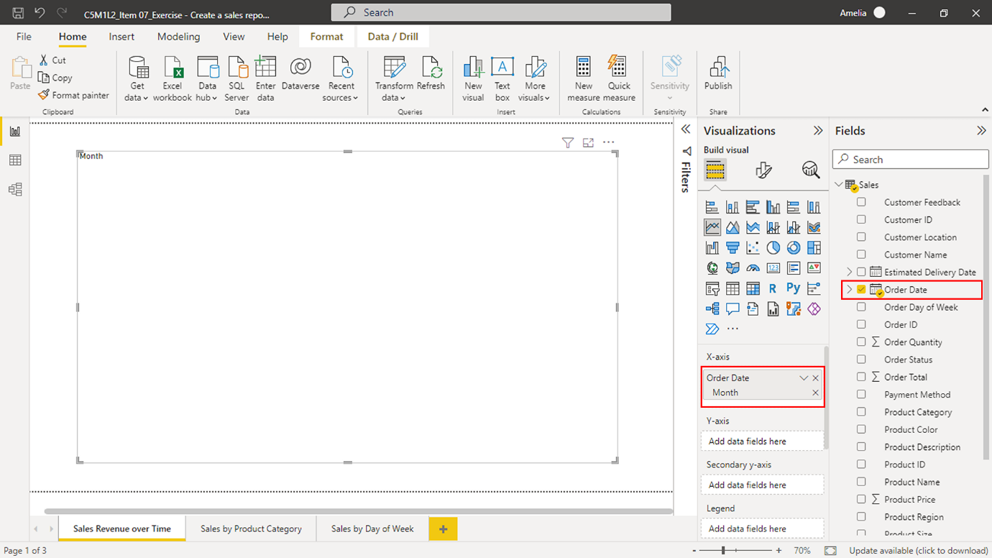

1. Next, locate **Order Total** in the **Fields** pane. Select it and drag it to the **Y-axis** field well. This action will define the **Y-Axis** of your line chart, representing the total sales.

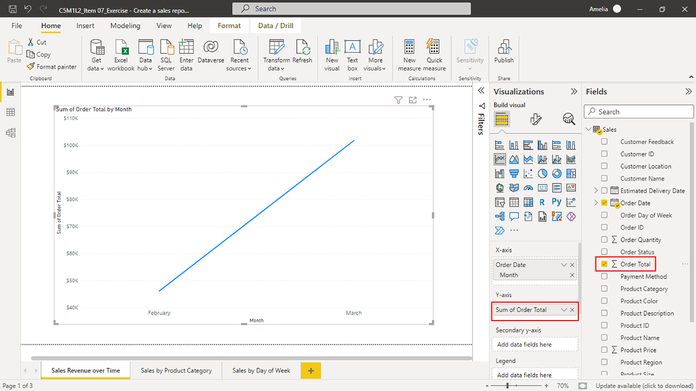

Your line chart now visualizes total sales over time. The **Order Date** field allows for tracking sales trends across different periods, while the **Order Total** quantifies the total sales for each date. You can change the chart's size by clicking and dragging its edges.

**Step 2: Create a pie chart for sales by product category**

Your next instruction was to create a pie chart, a circular statistical graphic divided into slices to illustrate numerical distribution. The aim is to create a pie chart of sales by product category to visualize each product category's contribution to total sales for Adventure Works. Combined with the line chart showing sales revenue over time, it gives a comprehensive view of the sales performance, allowing decision-makers to see the “when” and the “what” of sales revenue.

1. Begin by selecting the **Sales by Product Category** page.
2. To create a pie chart, move to the **Visualizations** pane and select the **Pie chart** icon. A blank pie chart box will appear in your report canvas.

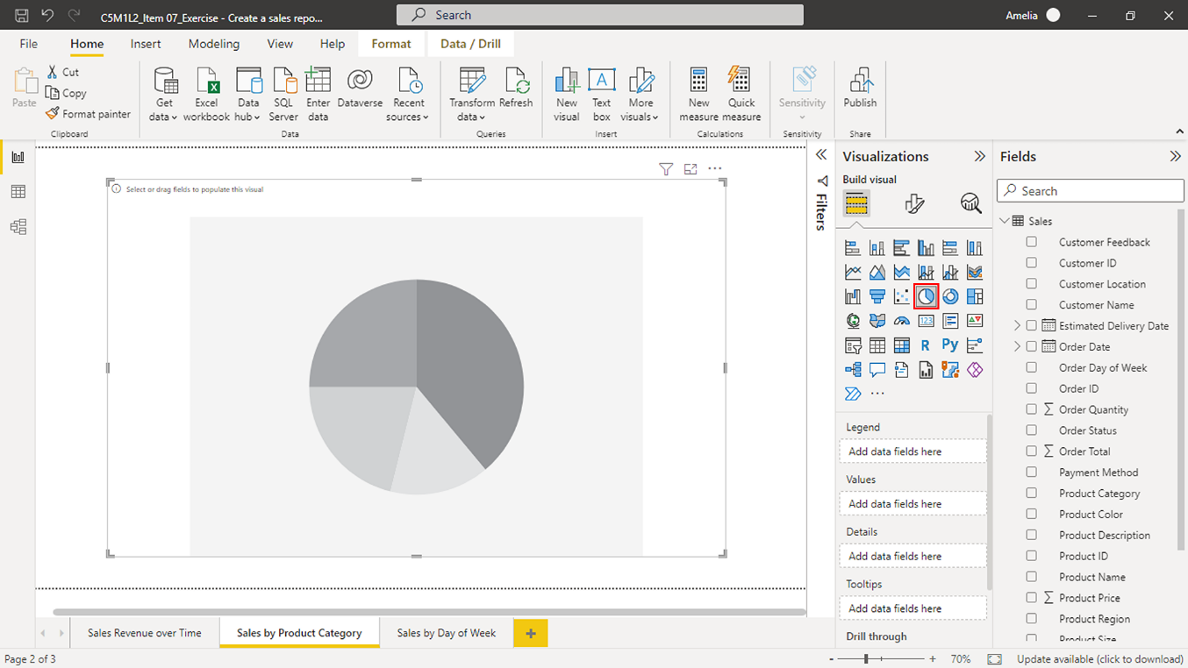

1. The next step is to add data to your pie chart. Select the **Product Category** field in the Adventure Works sales dataset, hold down the mouse button, and then drag the field over to the **Legend** box under the **Visualizations** pane. **Note:** The **Legend** box represents the categories in your pie chart, with each category assigned a different color in your chart for easy distinction. Adding the **Product Category** field to the **Legend** box tells Power BI that you want to show sales data for each product category in your pie chart.

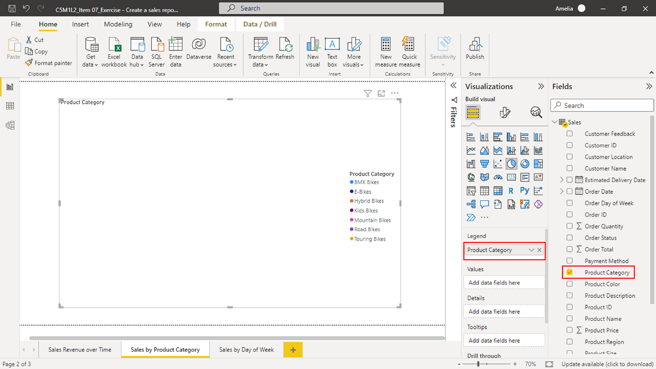

1. Next, find the **Order Total** field, which represents the total sales for each order. Select **Order Total** and then drag it over to the **Values** box. **Note:** The **Values** box defines what the pie chart measures. In this case, it's the total sales for each product category. By adding **Order Total** to the **Values** box, you set the pie chart to display the proportion of total sales represented by each product category.

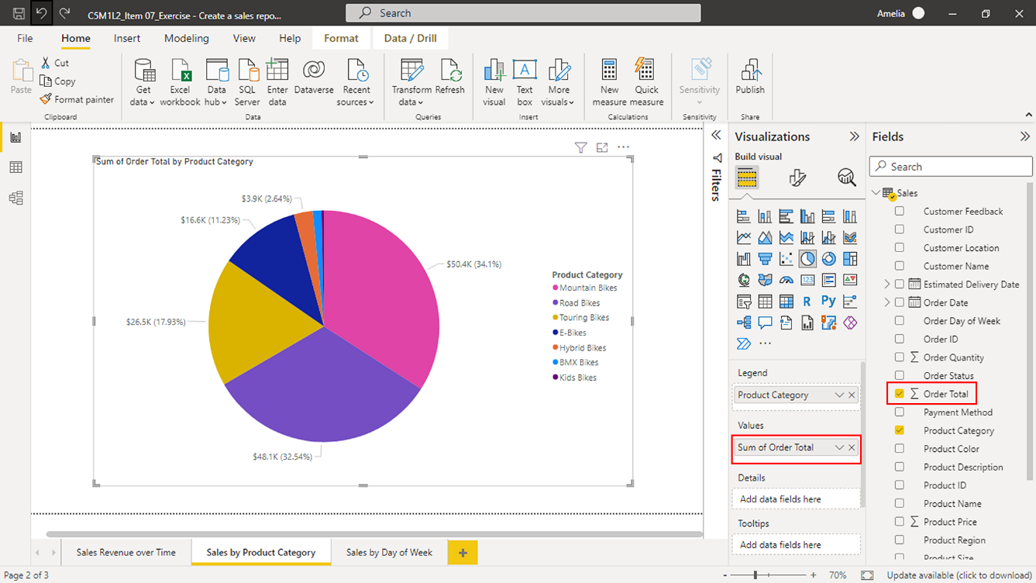

By completing these steps, your pie chart will come to life on your report canvas. Each slice of the pie represents a different product category, and their sizes correspond to the total sales for that category. Viewers can hover over each slice to display a tooltip with the exact sales figure.

**Step 3: Create a stacked bar chart for sales by day of the week**

Now you need to create a stacked bar chart that visualizes sales by the day of the week. Understanding product sales by day of the week can help Adventure Works identify customer buying patterns and adjust inventory, marketing, and sales strategies accordingly. For example, if sales of bikes are high on a Monday, the company might want to increase its stock based on the increased demand.

1. Select the **Sales by Day of Week** page.
2. To create a blank bar chart for this analysis, navigate to the **Visualizations** pane and select the **Stacked bar chart** icon. An empty bar chart box should now be on your report canvas. **Tip:** The **Stacked bar chart** is best suited for comparing different categories of a variable (in this case, days of the week) against a numerical value (total sales).

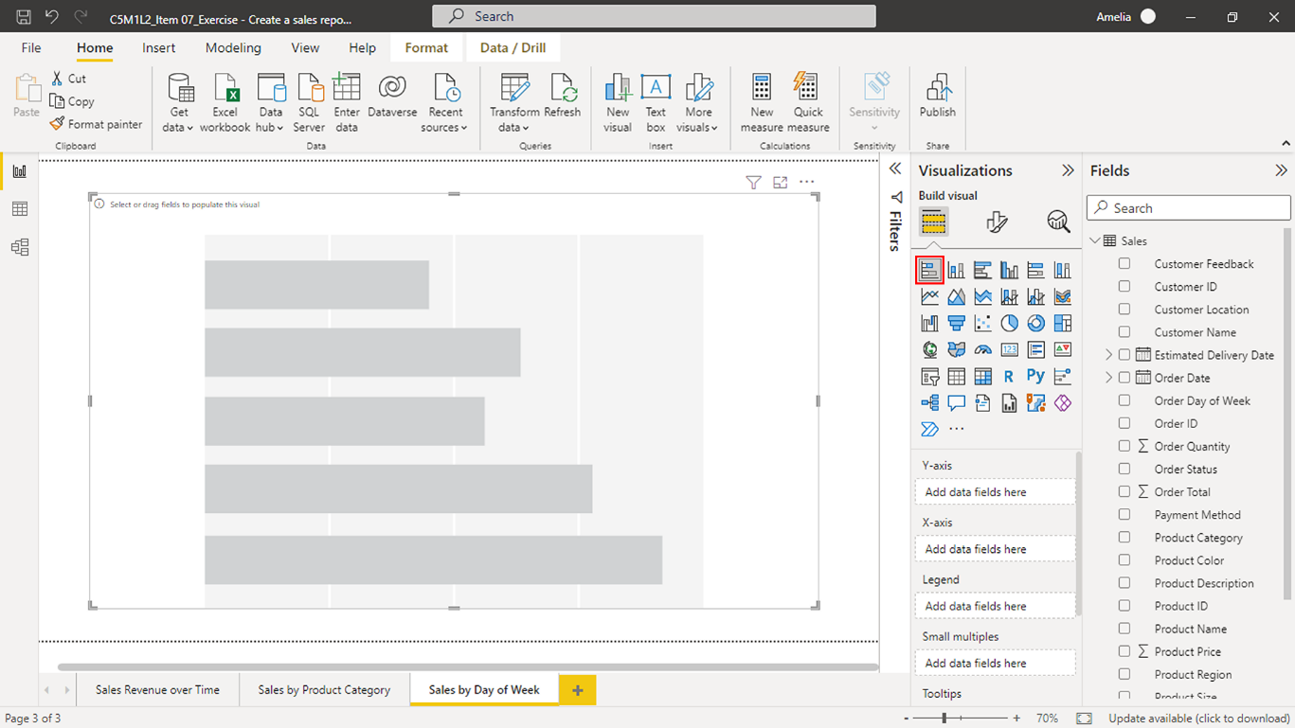

1. Select the **Order Day of Week** field and drag it to the **Y-axis** box to add data to your bar chart. **Note:** This field can reveal sales trends by capturing the day of the week each order was placed. For example, Adventure Works may find that most orders are placed on a specific day.

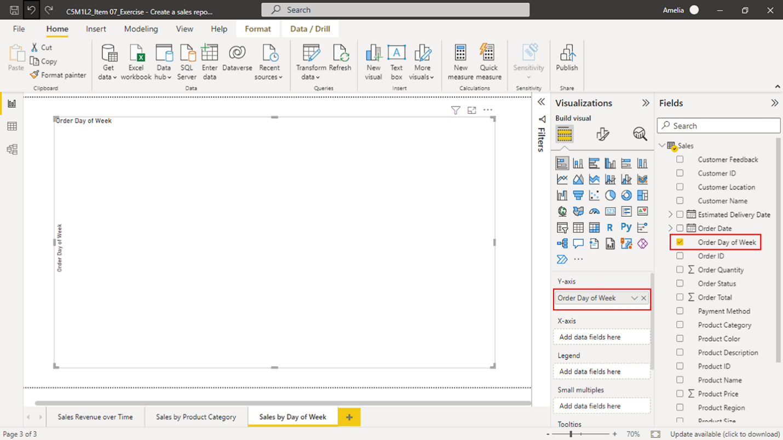

1. Next, select and drag the **Order Total** field to the **X-axis** box. This action tells Power BI to populate the bars of your chart with the total sales values.

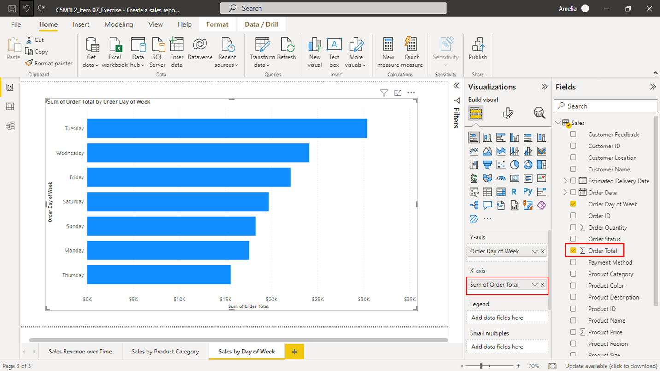

These steps should fully populate your stacked bar chart. Each bar represents a different day of the week, and the height of each bar signifies the total sales made on that day.

**Step 4: Add a slicer visual to alter the data to reflect changes**

Slicers can provide Adventure Works with a way to filter data interactively, enabling stakeholders to select one or more items and filter the rest of the visuals in the report accordingly. For instance, adding a slicer for **Order Date** would allow viewers to filter all visuals to display data from a specific time range. This could be invaluable for time-bound sales analysis—such as month-end sales, quarterly performance, or year-over-year trends—which are crucial for strategic planning and decision-making.

1. In the **Visualizations** pane, select the **Slicer** icon to add an empty slicer box to your report canvas.

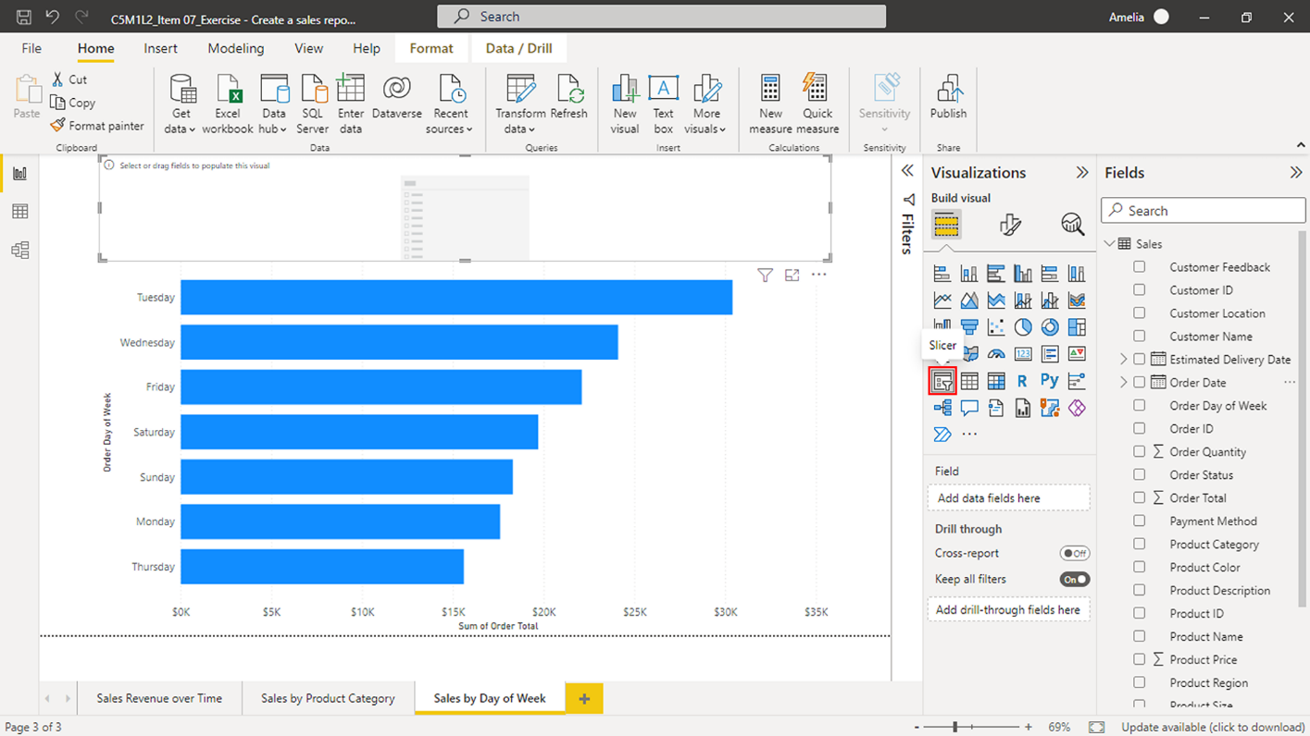

1. To add data to your **slicer**, select and hold the **Order Date** field from your dataset in the **Fields** pane. Then, drag it to the **Field** area under the **Visualizations** pane. Release the mouse button to populate the **slicer** with data from the **Order Date** field.

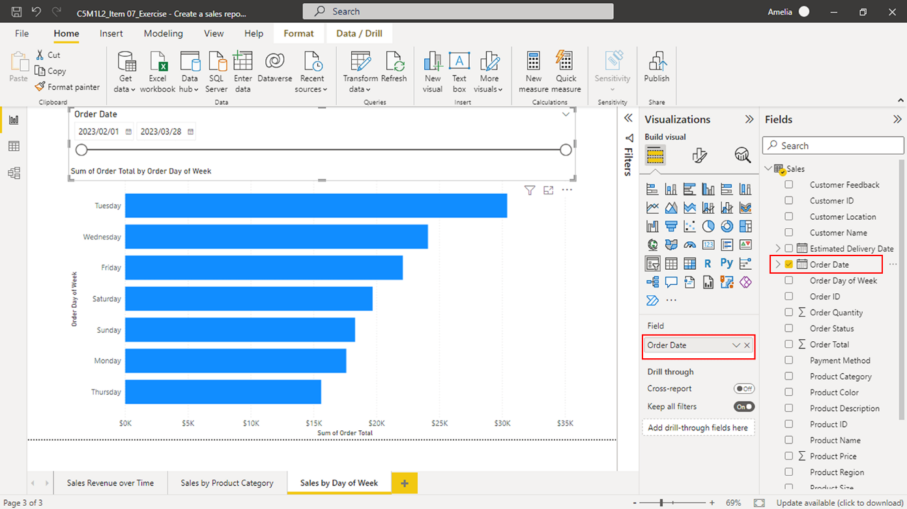

1. A range of dates will appear after adding the **Order Date** to the slicer. **Note:** By default, Power BI automatically recognizes the **Order Date** field as containing date data and thus provides a slider for ease of use. This slider will allow stakeholders to adjust the range of dates they want to examine data for in the report.

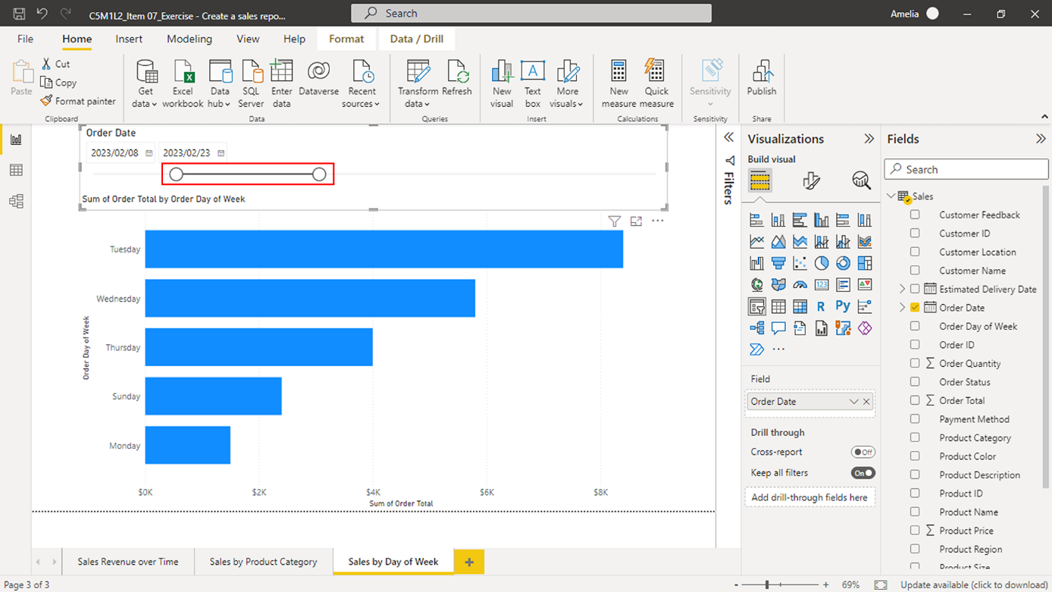

You have now added an interactive slicer to your sales report. Anytime a user adjusts the range on the **Order Date** slicer, all visuals in the report will update to reflect the selected date range. Slicers empower you to create informative, engaging, and flexible reports for users, catering to various data analysis needs and preferences.

**Conclusion**

By creating your own visualizations in the *Create a sales report* exercise, you gained first-hand experience using Power BI to convert raw data into easily understandable insights. You transformed sales data into an interactive story that conveys Adventure Works' sales revenue over time! Companies like Adventure Works can use reports like the one you created to make data-driven decisions, essential for driving business growth in today's data-rich world.